Sadhana Boddhula, Jessica Dang, Courtney Kowaluk

Marcia Rapchak

CS 1980 Capstone

### Website Redesign and Content Integration for Inclusive Teaching

Redesigning the University of Pittsburgh's Inclusive Teaching website aims to enhance functionality, content, and aesthetics, catering not just to local faculty but educators nationwide. By streamlining design and navigation while enriching content, our aim is a user-friendly aesthetically-pleasing platform for accessing inclusive teaching resources. Two rounds of usability tests were used to refine redesign ideas and test if the final design was reasonable. We had plans for accessibility features and live updates on related events, however those were stretch goals. Detailed project planning in the early stages ensured we had clear milestones and deliverables, setting expectations for a complete transformation.

In response to the need for more comprehensive resources on inclusive teaching, the University of Pittsburgh Diversity and Inclusion program initiated a redesign of its Inclusive Teaching website. This redesign aimed to extend its reach beyond local faculty to educators nationwide, emphasizing a user-friendly interface, enriched and newly-integrated content, and improved navigation. The project was sponsored by Dr. Marcia Rapchak, who advocated for a platform that could serve as a central hub for resources on inclusive teaching practices.

The process of redesigning and developing the website initially strayed a bit from our original timeline. We began the process by meeting with our sponsor, compiling all of the issues, and discussing potential changes. After doing an inventory of all issues with the site, we got them approved by our sponsor and moved forward with the changes. We found broken links, empty pages, confusing layout and navigation issues, among other small issues. We then took the changes proposed and made mockups for design and navigational improvements, allowing us to get feedback from our sponsor and choose which design she would prefer. During this process, we started looking into alternative website hosting, which Dr. Rosta Farzan requested. We reached out to Pitt IT’s hosting service because our sponsors initially believed that the startup time with the site was slow, but after proving that was not the case, Dr. Farzan decided against alternative hosting, and chose to stay on WordPress. There was ambiguity in the hosting service, as the budget was also a concern, so we were unable to get a higher tier or budget for a different hosting website. This caused issues with the ability to input our own code, as well as certain design elements that were limited.

We formed our usability testing methodology, which evolved as we ran into issues during the initial tests. We decided to have each user embody a different user story and give them 3-4 tasks based on each user story. This allowed us to narrow down where the majority of issues in the site lie. In order to conduct usability testing, we built a prototype using both Figma and PowerPoint and reached out to users from all backgrounds, including Undergraduate Teaching Assistants, Ph.D. Students, and Undergraduate Students, to have them participate in tests. We refined our process as the testing went on. The user testing sessions and post-session feedback was analyzed and incorporated into the website changes, and then we did a smaller second round of user testing to verify that the changes we made were adequate.

For our user testing, we first created one prototype in PowerPoint, as it has been successfully used in prototypes in the past. However, during the course of testing with the first two participants, we encountered some issues where the users wanted to scroll with a trackpad on the prototype, and we were unable to disable the feature of scrolling while presenting. We mitigated this by using a mouse and telling the third user not to scroll. Ultimately, we decided redesign the prototype in Figma, allowing us to have more control over the screen size, mapping of elements, and overall presentation, as it has native functionality for prototyping. This slowed down our process of user testing briefly, but the tests with the other eight participants had no issues with the prototypes.

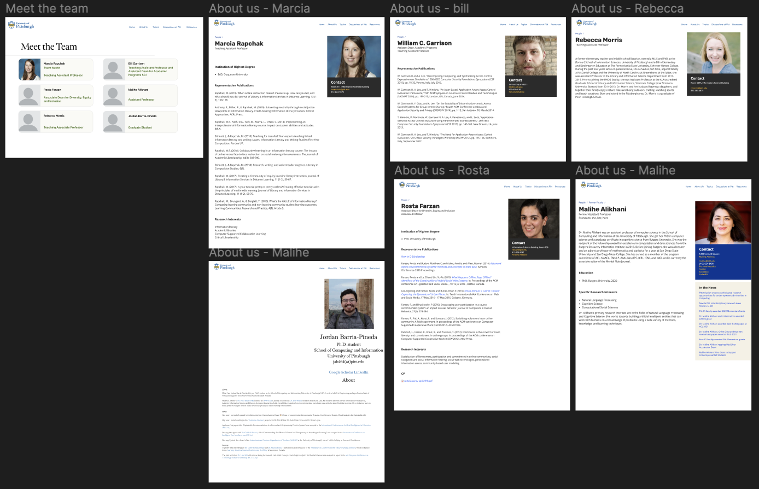The images below depict the initial prototype created through Figma. Figma allows their users to click through the pages to represent a working site, which helped us understand how users complete each task while observing the ‘think-a-loud' process. The prototype also gave us an initial idea of how we wanted to structure the site and what images and layout we wanted to use. The first image shows the “About Us” pages we tested in the redesign. The second image shows the navigation and layout of content and resource pages, the main feature of the website. Figma proved to be a more useful tool that worked more seamlessly than PowerPoint, though it did affect our timeline somewhat.

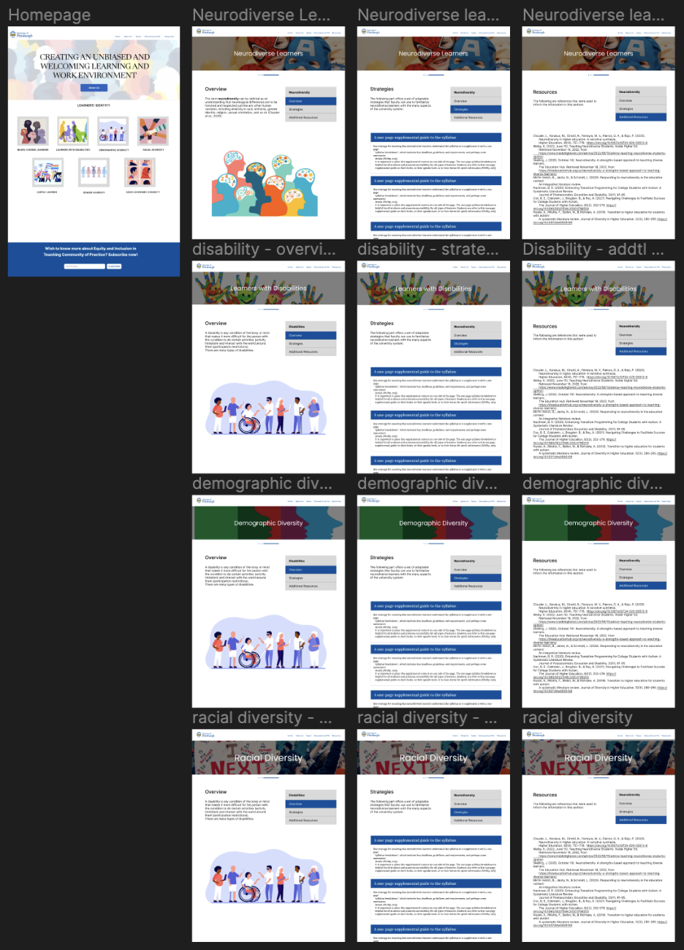

Participants included undergraduates, PhD students, teaching assistants, and professors from the School of Computing and Information. This diverse group provided a wide range of perspectives on the website’s usability and design. We had ten users in the first round of usability testing, and 3 users in the second round.

The usability tests highlighted several key areas for improvement, which were addressed in the iterative design process:

* **First Round**: Identified critical issues in navigation and content accessibility.
* **Revisions**: Adjustments were made based on feedback, focusing on simplifying navigation and removing unnecessary sections.
* **Second Round**: Showed significant improvements in user satisfaction and reduced navigation difficulties.

Our methodology for the usability testing was to have each user sign a consent form, receive an explanation of the project and its purpose, receive a list of tasks they are to complete, and then conduct a think-aloud. A think-aloud is a method of user testing where the users speak out loud as they complete tasks, giving a window into their mind and thought processes. The users are recorded during their sessions, and then later analyzed for critical incidents, good and bad. For the first three sessions, we recorded users using a camera, viewing them and the screen. However, after finding it a bit more difficult to analyze the data, we switched to using Zoom and recording the screen and audio. This made it easier to follow mouse movements and pinpoint hesitation. We looked through the think-aloud recordings, compiled critical incidents where users had issues, expressed frustration, or expressed that they particularly enjoyed something. After the think-aloud, we asked the users to take a brief survey. We took feedback from the surveys, user testing, and critical incidents, and compiled a list of changes we think we should implement beyond the initial prototype changes. We brought these changes to our sponsor, and then began implementing them on our website.

For the second round of user testing, we used the live website instead of a prototype. We wanted to see if users responded more positively after our changes from the feedback, and make sure there weren’t any bugs we encountered. We had fewer users in the second round of the study, due to time constraints. The 3 users went through a similar process to the first, where they followed the process of a think-aloud to complete tasks. The users gave feedback and answered survey questions. Their critical incidents trended towards being more positive, with fewer difficulties. Some users found bugs in our updated site, such as email links not being formatted correctly for the members of the team and a duplicate on the “About Us” page. The further user testing allowed us to make these final changes, and ensure that the website is functioning properly.

Feedback from users was generally positive, particularly in terms of the website's improved layout and intuitive design. The changes made were well received, indicating that the redesign successfully addressed the initial concerns. Some of the feedback in both sets of user testing was constructive, allowing us to make more user-informed changes. The feedback in the second round of user testing showed a significant decrease in critical incidents where they had issues, as some menus were named in a misleading way.

The iterative design process was crucial in meeting the diverse needs of the website's users. By engaging with users through multiple rounds of testing, the project team could refine the website to ensure it was both functional and aesthetically pleasing. The involvement of a broad range of participants from the university ensured that the redesigned website would serve as a comprehensive resource for inclusive teaching practices.

We ran into some difficulties with the logistics of user testing. Our timeline had user testing set to occur around the time of spring break, and that caused some issues with scheduling. We were unable to get in contact with many of the users we reached out to, or they did not express interest in user testing. We managed to get 10 users in the initial round of usability testing, which was enough to get reasonable feedback. For our second round, however, it was near the end of the semester, and we did not have much time to get users together to conduct testing. We would have ideally had more than 3 users, however those users did provide valuable feedback and find bugs.

|  |  |
| --- | --- |
| The images shown are the same page on the site in both the mobile and website viewing platforms. The image below depicts how the menu is meant to be placed and the snippet under the overview clearly aligns with the menu. This was a key issue that we faced since the WordPress plan, we were using did not allow us to integrate a menu into the website since it is part of a higher package. To work around this issue, we formatted buttons into a menu format to mimic the look and functionality as if the collection of buttons was a menu. In the future, if the plan was upgraded, we would be able to use an actual menu instead. The layout and functionality work on the website but is not compatible with mobile devices. As we turn to the mobile platform, the "menu” becomes disorganized and reverts to actual buttons as shown in the image below. |  |

Many of our challenges in this project were related to the hosting platform, WordPress. Since the department did not want to move forward with hosting on the University of Pittsburgh’s network, and there were budgetary issues that did not allow us to move platforms or purchase a higher tier on WordPress, we were stuck with the current web plan. We initially had plans of rebuilding the website with CSS, but the tier on WordPress did not enable us to do so. We also built our prototypes and tested them without considering the WordPress limitations, so we had to find workarounds, like the buttons mentioned above.

Many of the requirements from our sponsor were ambiguous, leading us to branch out on our own in terms of design. We each did research on web design patterns and ideal layouts, which we created during the early stages, and let our sponsor choose the one she liked best. Throughout the project, we occasionally wished we had more solid guidelines, however it was nice to be able to have freedom to design anything within the scope of the project.

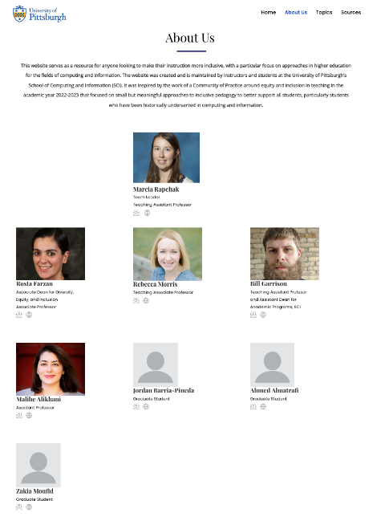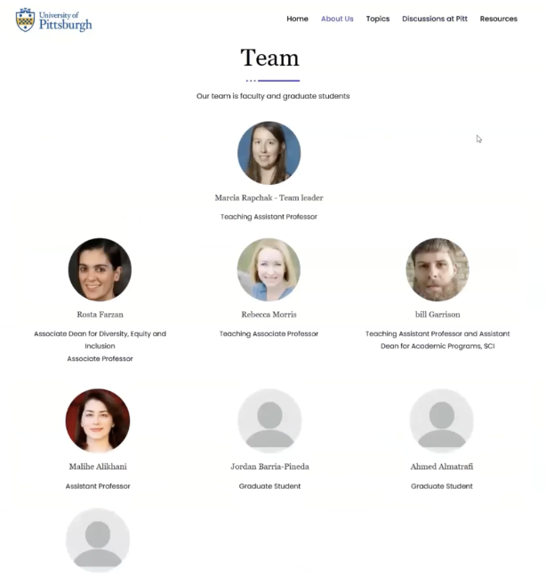Overall, we are satisfied with the output of the project. The website is functional, our sponsor is satisfied, and we believe the design looks more consistent and appealing than the previous design of the website. We tried to stick to colors close to Pitt’s dark blue, hoping it will feel a bit more like a University-hosted site. The images below are before and after images of the “About Us” page, showcasing the improved design and functionality.

This project exemplifies how academic websites can be transformed into dynamic, inclusive educational tools through thoughtful redesign and continuous user feedback. It sets a benchmark for similar initiatives aiming to enhance educational resources across various disciplines.

Looking ahead, the website will continue to evolve with the Department of Diversity, Equity, and Inclusion, incorporating the latest in educational research and technological advancements to support inclusive teaching. Ongoing updates and community engagement will be critical in maintaining the website’s relevance and effectiveness as an educational resource. The website's production will be improved by increasing capability on all platforms. Currently, the web platform is compatible with the site, but the layout in a mobile platform needs improvement.

In conclusion, the redesign of the Inclusive Teaching website has significantly enhanced its functionality, informative nature, and user engagement. Through a rigorous process of user testing and feedback integration, the website now offers a more intuitive and professional platform for educators seeking resources on inclusive teaching. The project's success lays a foundation for ongoing improvements and ensures the website remains a vital tool for fostering equitable learning environments.